

NIRMA UNIVERSITY

INSTITUTE OF TECHNOLOGY

**Mini Project Report**

**On**

**“MATCHSTICK GAME”**

**B. Tech CSE**

**(2CS101 Computer Programming)**

Submitted by: -

Diksha Sharma 21cek084

**INDEX**

1. Title of the project………………………………….03
2. Objective…………………………………………...03
3. Introduction………………………………………...03
4. Methodology
5. Flowchart……………………………………...04
6. Features of the C language used…………...05-09
7. Output…………………………………………..10-12

**TITLE OF THE PROJECT:** Matchstick game

**OBJECTIVE:**

The objective of our mini project is to make a matchstick game.

**INTRODUCTION:**

Matchstick game is very popular and is fairly simple in itself. It is actually a two-player game. In this game, there are total 21 matchsticks. Each player has to pick any number of matchsticks between 0 to 5 one after another when it’s their turn. And the person to pick up the last matchstick loses the game.

Here, we have made the project on matchstick game which provides us with two options of playing: -

1. Player x Player: - Here, the game can be played between two friends.
2. Player x Computer: - Here, the game is played between the computer and a player.

Whomever of the two players or the player and the computer picks the last matchstick loses the game and the other player wins the game.

**METHODOLOGY:**

* **Flowchart**

START

Instructions for playing game

**Choice 1**

1= To play with computer

2= To play with another player

**Choice 2**

Player 1 choose the no. of matchstick

mstick=21

**Yes**

Player 1>5

Please enter from 1 to 5

Player enter the no. of matchstick

**No**

mstick=mstick-player

mstick= mstick-player1

**No**

mstick>1

**No**

mstick>1

Player 2 lost the match

**Yes**

Player won

**Yes**

Player 2 choose the no. of matchstick

STOP

Computer chooses no. of sticks

**Yes**

Player 2>5

STOP

mstick= mstick-computer

Please enter from 1 to 5

**No**

**No**

mstick= mstick-player2

mstick>1

**No**

mstick>1

Computer won

**Yes**

Player 1 lost the match

**Yes**

STOP

STOP

* **Features of the C used:**

1. Functions: -

1. Void inst ( )

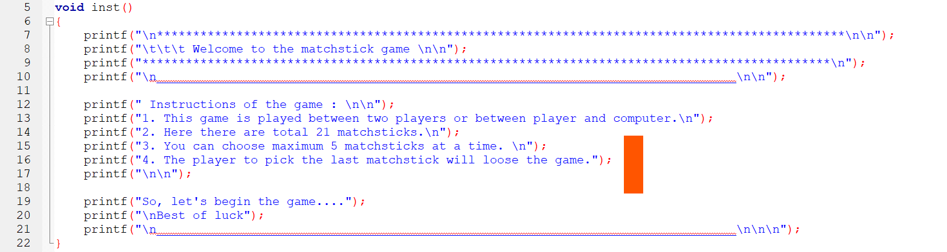

1. Void main ( )

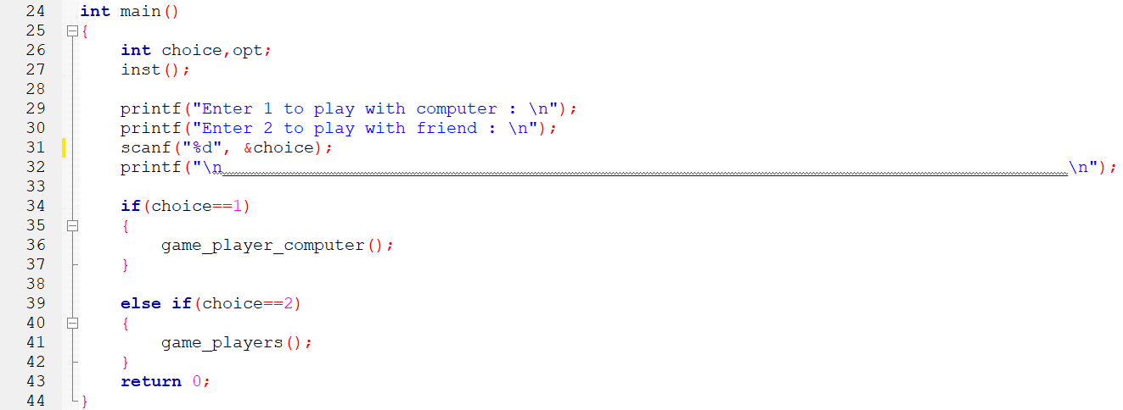

1. Void game_players ( )

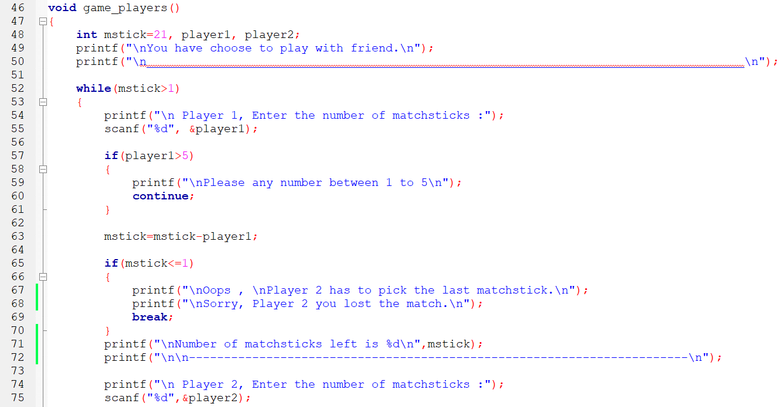

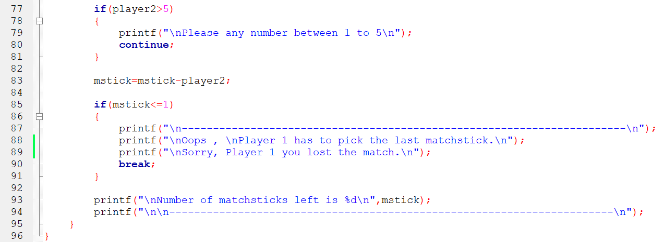

1. Void game_player_computer ( )

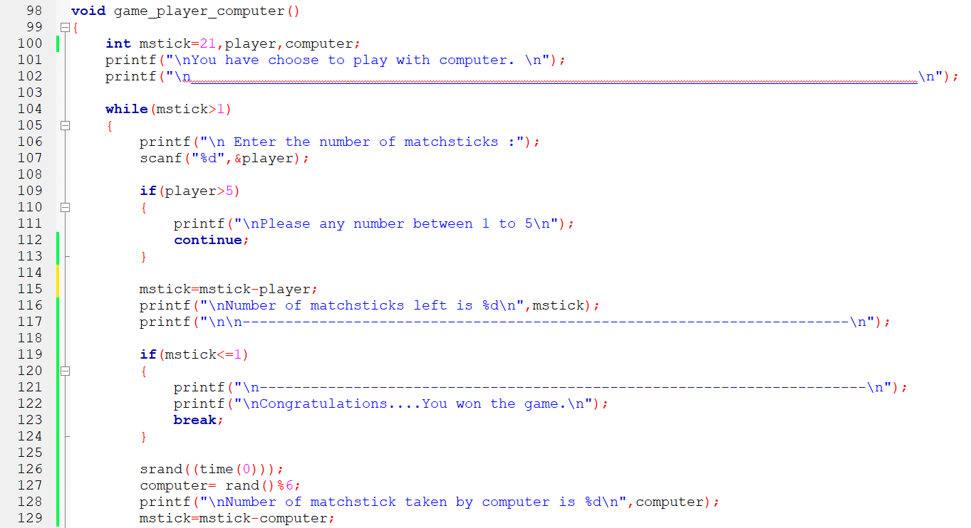

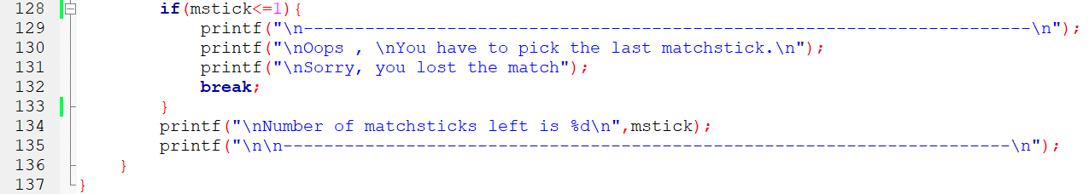

2. Srand( ) function: -



3. Conditional statements: -

1. If statements

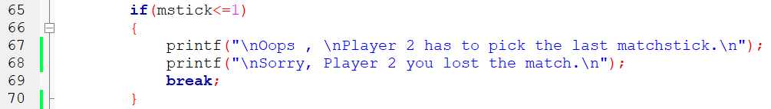

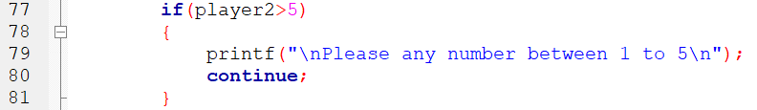

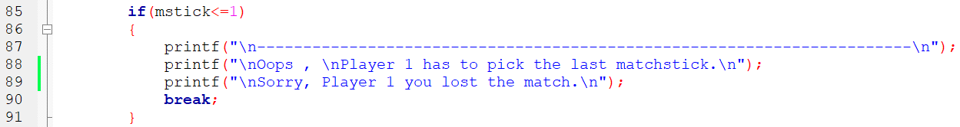

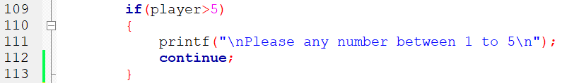

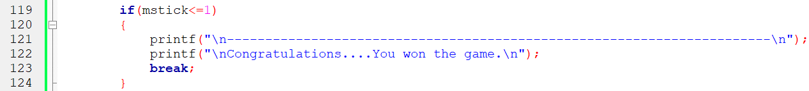

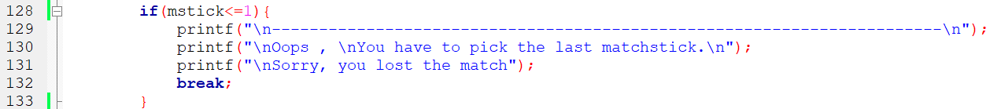

1. If…else if statements

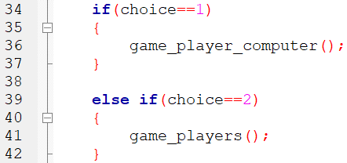

4. Loop Constructs: -

1. While loop

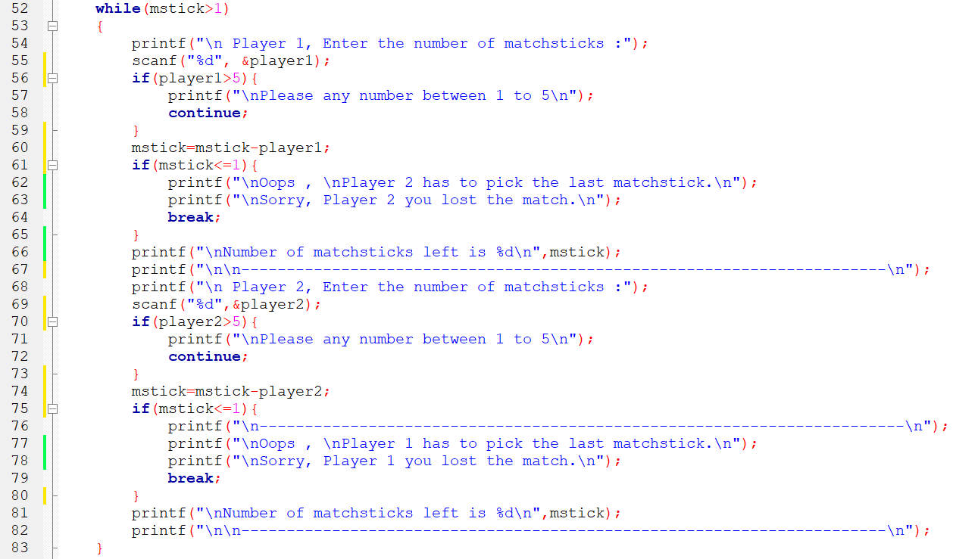

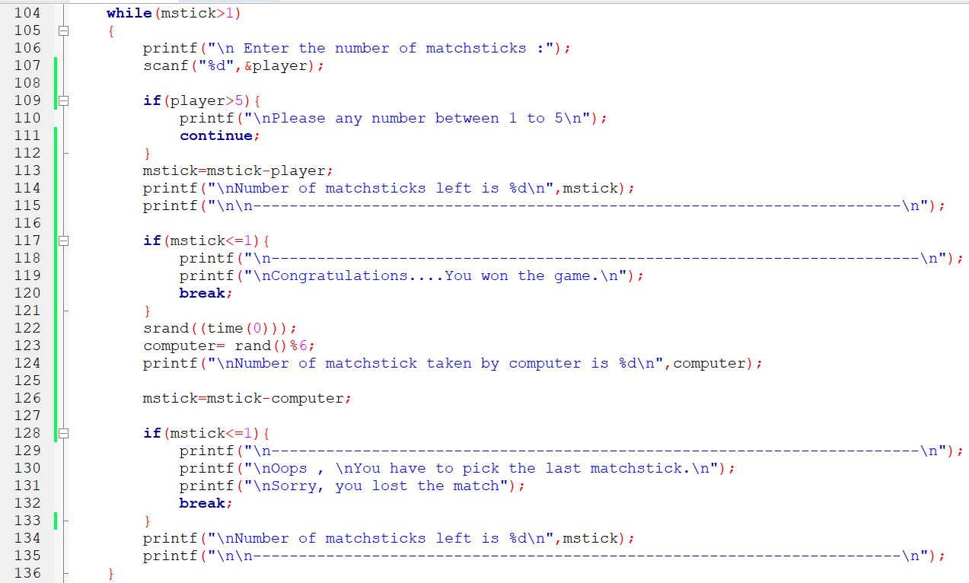

**Output: -**

Instructions on how to play the game.

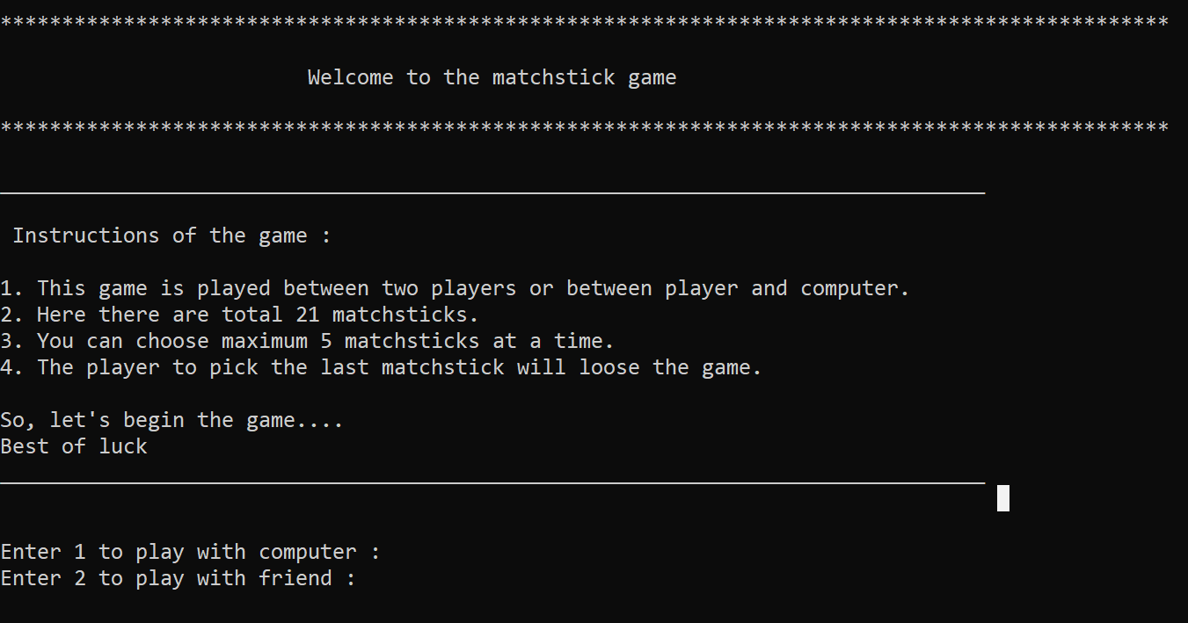

Player x computer

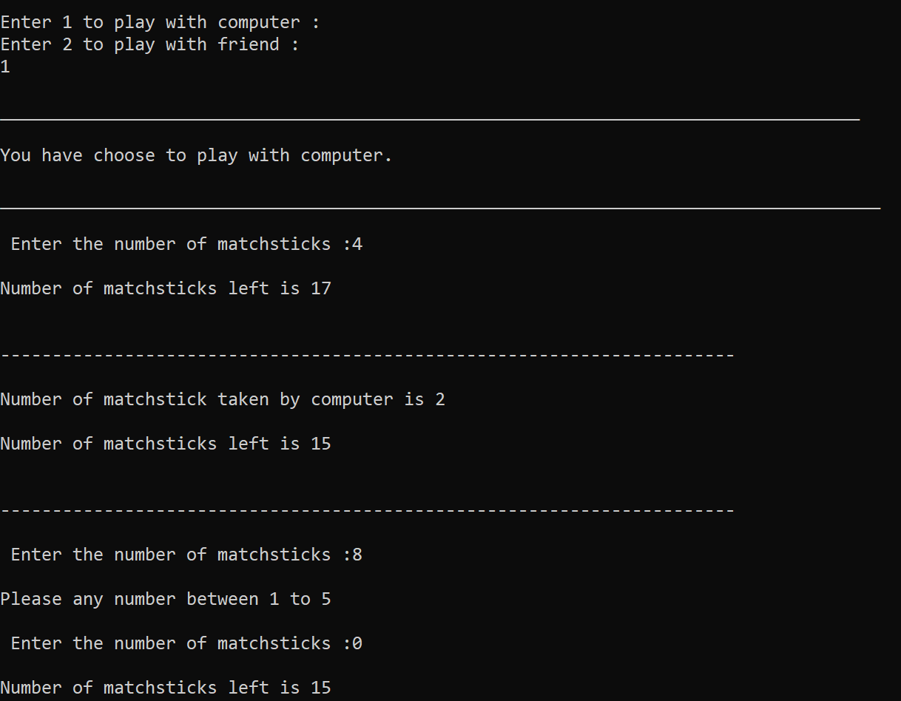

Player won the game

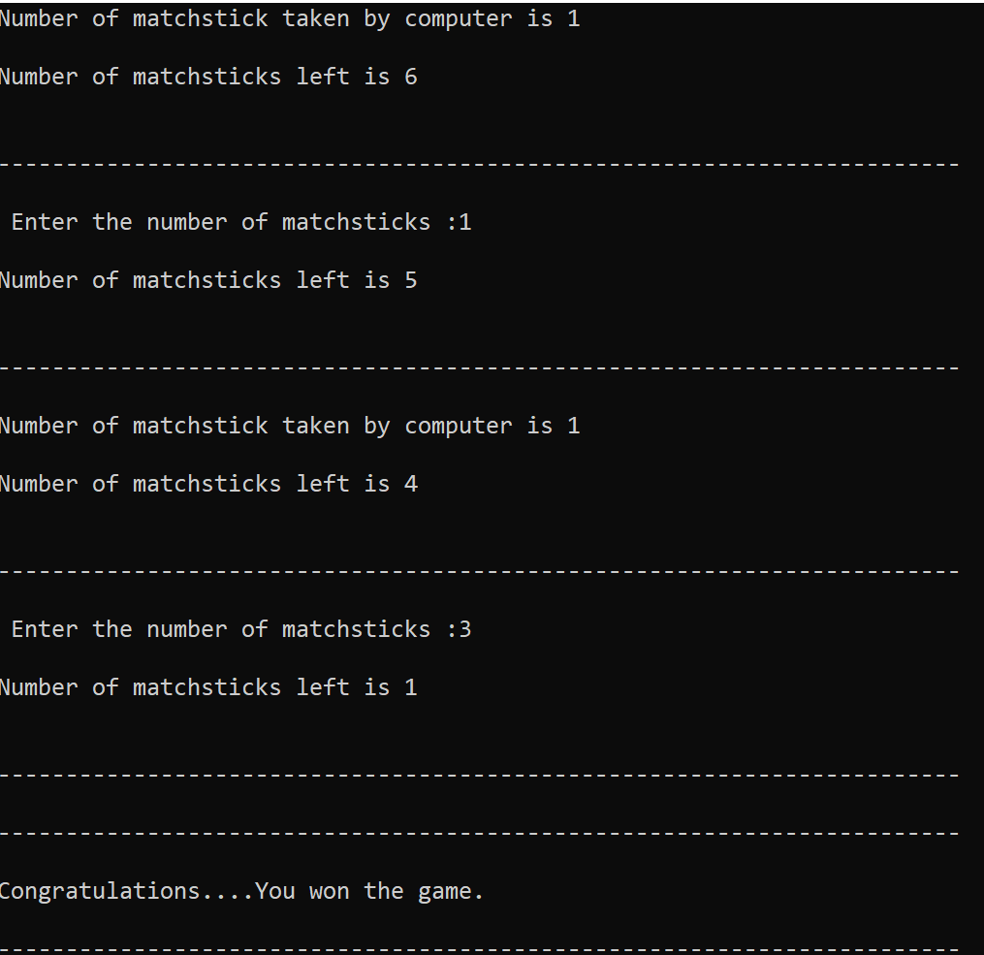

Computer won the game

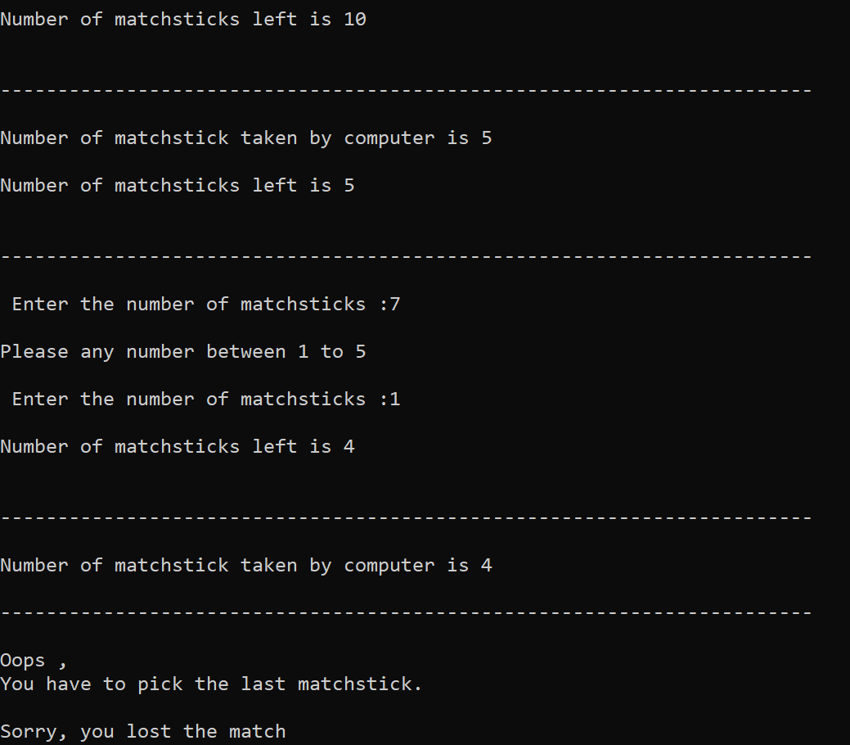

Player x player

